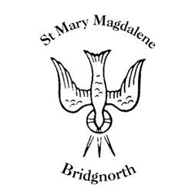

Sunday Services

Sunday 31st August
10.30am Holy Communion
Led by Revd. Suzan Wiliams

NEXT WEEK

Wednesday 3rd September
10.30am Holy Communion
Led by Revd. Suzan Williams

12.30pm Funeral for the late Eileen Eykelestam

Thursday 4th September
10.00am Little Stars

Saturday 6th September
10.00am Coffee Shop

www.bridgnorthteamministry.org.uk

