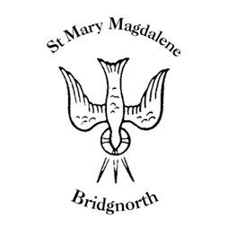

Sunday Services

Sunday 24th August
10.30am Morning Prayer
Led by Ian Terry

NEXT WEEK

Wednesday 27th August
10.30am Holy Communion
Led by Revd. Simon Boxall

Friday 29th August
12pm Funeral for the late Sheila Elizabeth Davies

Saturday 30th August
10.00am Coffee Shop

www.bridgnorthteamministry.org.uk

