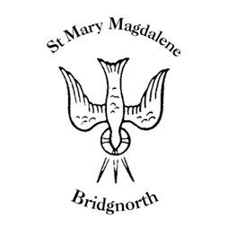

Sunday Services

Sunday 20th July
10.30am Morning Prayer
Led by Roger Taylor

NEXT WEEK

Monday 21st July
Lady Clare’s Consort: The Art of Imitation choral ensemble

Saturday 26th July
10.00am Coffee Shop

Sunday 27th July
3.00pm District bellringers Quarter Peal

www.bridgnorthteamministry.org.uk

