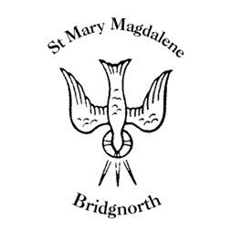

Sunday Services

Sunday 29th June
10.30am Family Service/Baptism
Led by Revd. Suzan Williams

6pm Service of Remembrance

NEXT WEEK

Thursday 3rd July
10.00am Little Stars

Friday 4th July
3.30pm Birmingham Bach Choir Rehearsal

Saturday 5th July
10.00am Coffee Shop

www.bridgnorthteamministry.org.uk

